

**Project Proposal**

**VowEssentials**

**Supervisor: Sir Kamran**

***By***

**Nabila Naz Roll No: 068464**

**Marwa Ali Roll No: 068439**

***Bachelor of Science in Information Technology (2021-2025)***

**SCOPE DOCUMENT REVSION HISTORY**

|  |  |  |
| --- | --- | --- |
| **NO.** | **Comment** | **Action** |
|  |  |  |
|  |  |  |
|  |  |  |
|  |  |  |
|  |  |  |
|  |  |  |

**Date: Supervisor Signature:**

**Table of Contents**

Abstract 5

Introduction 6

Problem Statement 6

Problem Solution for Proposed System 6

Project Overview Statement 6

Related System Analysis/Literature Review 7

Table 1- Related System Analysis with proposed project solution 7

Pros/Benefits of Proposed System 8

Scope 8

Modules 8

Details of Modules 9

Product Catalog 9

Customer Browsing and Shopping 9

Product Customization 9

Chat Feature 9

Order Management 9

Customer Reviews and Feedback 9

Payment Gateway Integration 9

Add to cart 9

System Limitations/Constraints 10

Software Process Methodology 10

a) Agile-Scrum Software Model 10

b) SCRUM Process Model 10

Gantt chart of Proposed System 11

Tools and Technologies 11

Table 2- Tools and Technologies for Proposed Project 11

Table 3-Team Member Work Division for Proposed Project 12

Table 4-Project Stakeholders for Proposed Project 12

Mock-up 13

References 16

**Project Category:**

A

-

Desktop Application/Information System

B

-

Web Application/Web Application based Information System

C

-

Problem Solving and Artificial Intelligence

D

-

Simulation and Modeling

E

-

Smartphone Application

F

-

Smartphone Game

G

-

Networks

H

-

Image Processing

Other (specify category)



# Abstract

This project is about creating a simple and user-friendly app for dowry-related shopping. Shopkeepers can create their profiles, upload product details with images, prices and locations and manage their catalogs and orders. Customers can browse products, view details, chat with shopkeepers and place orders.

The app ensures high-quality products and allows customers to visit the shop using the shopkeeper's live location. Customers can also customize products according to their needs, making the shopping experience easy and personalized. This platform connects customers and shopkeepers in a convenient and efficient way.

## Introduction

Vow Essentials is created with the goal of offering customers the best products that meet their preferences and needs. Our platform allows customers to communicate directly with shopkeepers, inquire about product details, request customization and place orders according to their preferences, without the involvement of third parties. This platform allows customers to browse a variety of products, connect with shopkeepers, and make purchases with confidence. Vow Essentials is dedicated to providing a hassle-free shopping experience, where customers can easily find exactly what they need for special life events like weddings, all while ensuring quality and satisfaction.

## Problem Statement

In traditional dowry shopping, customers face challenges such as limited access to product options, time-consuming visits to multiple shops, lack of customization and difficulties in comparing prices and quality. Additionally, shopkeepers struggle to reach a broader customer base and efficiently manage orders and inquiries. Tosolves problem by offering a platform where customers can directly communicate with shopkeepers, ask for customizations and even visit the shop if they want. Customer can also buy a product by browsing catalogs. This creates a more personalized and hassle-free shopping experience, helping customers find exactly what they need for weddings without relying on intermediaries.

## Problem Solution for Proposed System

The Proposed Vow Essentials addresses the key issues faced by customers when shopping for wedding-related products, especially dowry items by offering a hassle-free and personalized shopping experience. The solution includes:

* Communicate directly with shopkeepers to inquire about products and request customizations.
* Purchase products without paying extra charges or relying on third-party intermediaries.
* Visit the shop in person by using the shopkeeper's shared location for a more transparent and confident shopping experience.
* Customers can customize products to suit their needs, ensuring they get exactly what they want.

## Project Overview Statement

Vow Essentials is an online platform designed to make wedding shopping easier, more affordable, and personalized. The platform connects customers directly with shopkeepers, allowing them to inquire about products, request customizations, and purchase items without any extra charges. Unlike traditional e-commerce platforms, Vow Essentials eliminates third-party intermediaries, ensuring a more direct and transparent shopping experience. Customers can browse a range of essential Dowry products, communicate with shopkeepers, and even visit shops in person using the shopkeeper’s shared location. The platform focuses on offering best-quality products that meet customers' specific needs, without the pressure of traditional dowry practices. Vow Essentials aims to provide a personalized and cost-effective shopping experience.

## Related System Analysis/Literature Review

In System Analysis we collect data from different document apps.

|  |  |  |  |  |  |  |
| --- | --- | --- | --- | --- | --- | --- |
| Mobile Application | Version | Released  On | **Feature** | | | |
| Direct Communication | Product Customization | Dowry-Specific Focus | Extra Charges |
| **OLX** | 19.0.5 | 2006 | ✖ | ✖ | ✖ | ✔ |
| **Daraz** | |  | | --- | | 6.2.3 |  |  | | --- | |  | | 2012 | ✖ | ✔ | ✖ | ✔ |
| **VowEssentials** | 1.0 | 2024 | ✔ | ✔ | ✔ | ✖ |

### Table 1- Related System Analysis with proposed project solution

|  |  |  |
| --- | --- | --- |
| **Application Name** | **Weakness** | **Project Proposed Solution** |
| **VowEssentials** | Limited Internet Access for Some  Customers.    No Immediate Product Testing.    Limited choices in furniture and  electronics Equipment. | Offline features, such as downloadable catalogs.  Include return or exchange policies.  Expands the selection with a larger variety of furniture, jewelry and electronics options. |

## Pros/Benefits of Proposed System

With this we have multiple advantages like.

1. Saves time
2. Cost-Effective
3. Encourages local businesses.
4. Customization options
5. Reduces physical work

## Scope

Vow Essentials focuses specifically on dowry shopping, where customers can browse products from shopkeepers' profiles, view product details, and make purchases. The key feature is that customers can customize these products according to their preferences, addressing the need for personalized dowry items. While online shopping is convenient, the platform also promotes the option for customers to visit the shop in person if desired, allowing them to interact with the shopkeeper directly. Vow Essentials aims to make wedding shopping more affordable, personalized, and convenient while supporting local businesses.

## Modules

* Login & Signup
* Customer profile
* Shopkeeper Profile
* Settings
* Customer Browsing and Shopping
* Product Catalog
* Chat Feature
* Order Management
* Customer Reviews and Feedback
* Add to cart
* Payment

### Details of Modules

**Login & Signup**

Allow users to create an account or log.

#### Shopkeeper Profile

Shopkeepers can create, update, and manage their profiles, including adding product categories, descriptions, prices, images, and location.

### Product Catalog

Shopkeepers can list their products, update product details, add customization options, and manage stock availability.

### Customer Browsing and Shopping

Customers can browse through shopkeepers' catalogs, view detailed product information, and search for items based on categories or preferences.

### Product Customization

Customers can customize the products according to their needs and preferences, such as size, color, or design.

### Chat Feature

A messaging system where customers can chat directly with shopkeepers to ask questions, inquire about products, or request customizations.

### Order Management

Customers can place orders, track order status, and manage payment options. Shopkeepers can view and manage customer orders.

### Customer Reviews and Feedback

Customers can leave reviews and feedback about products and shopkeepers, helping future customers make informed decisions.

### Payment Gateway Integration

A secure system to process payments, ensuring safe transactions for customers and shopkeepers.

### Add to cart

Users can add items to their cart and proceed to checkout.

## System Limitations/Constraints

* Dependence on Internet Connectivity.
* The quality and quantity of products depend on shopkeepers actively uploading and updating their catalogs.
* Focusing on dowry-related shopping may face criticism in regions where dowry practices are sensitive topics.
* Sensitive data like payments and chats need strong protection.
* Active shopkeeper participation is crucial for product updates.

➢Lack of touch/feel experience could reduce trust.

## Software Process Methodology

### a) Agile-Scrum Software Model

1. Agile software methodology is a set of repetitive and incremental process models. It is considered to be most flexible and easily maneuverable for restless requirement specifications environments. Unlike other process models where high formality is required and the specifications are expected to be known and verified before the commencement of design, agile models allow the use of increments or possible prototypes that can evolve into a more suited and validated requirements and eventually software application. Pressman (2004) defines it as a development pattern that encourages customer satisfaction and early incremental delivery of operational software; small, highly motivated project teams; informal methods; minimal software engineering work products; and overall development simplicity.
2. There are several evolving agile process models for different design scenarios which are considered flexible, incremental and repetitive in approach.

### b) SCRUM Process Model

There are several evolving agile process models for different design scenarios which are considered flexible, incremental and repetitive in approach. For this project, we would be using SCRUM Agile process model because of its support for object-oriented software design.

An Agile process model follows these activities:

* Planning
* Requirements Analysis
* Design
* Coding/Implementation
* Unit Testing
* Acceptance Testing

## Gantt chart of Proposed System

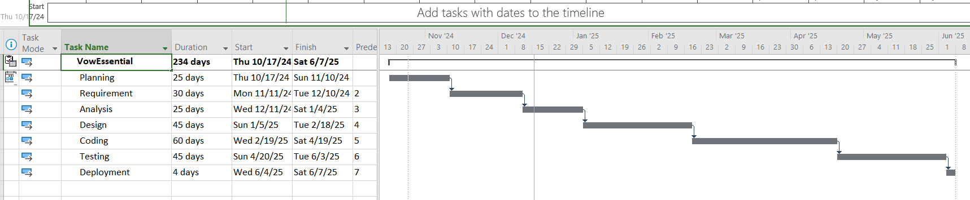

## Tools and Technologies

Below we mention some of major hardware/software tools and technologies with version number which will be used in implementation of the project.

### Table 2- Tools and Technologies for Proposed Project

Below we mention some of major tools and technologies which will be used in implementation of our project.

#### Programming Language

* XML
* Java

#### Database Management System

* SQLite
* Local Database

**Developmental Tools**

* Android Studio

#### Project Stakeholders and Roles

The project stakeholders and their roles are as:

### Table 3-Team Member Work Division for Proposed Project

|  |  |  |
| --- | --- | --- |
| **Student Name** | **Roll Number** | **Responsibilities/Modules** |
| Nabila Naz | 068464 | Frontend/Backend |
| Marwa Ali | 068439 | Frontend/Backend |

## Table 4-Project Stakeholders for Proposed Project

|  |  |
| --- | --- |
| **Project Sponsor** | * Nabila Naz * Marwa Ali |
| **Stakeholder** | Project Stake Holders with their roles and responsibilities.   * Visitors * Sellers * Developers |

### Mock-up

Here we are inserting mock-up regarding to our project for reviewing.

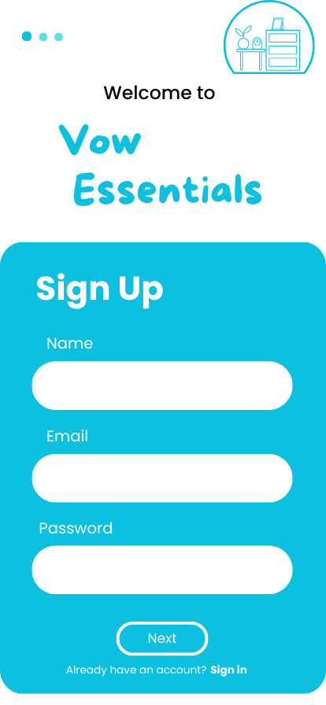

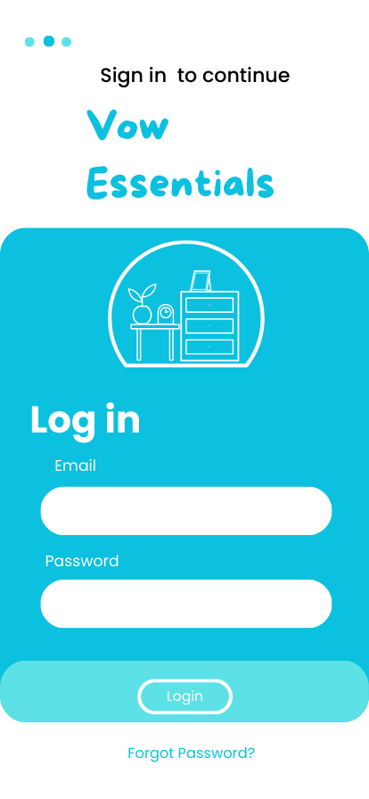

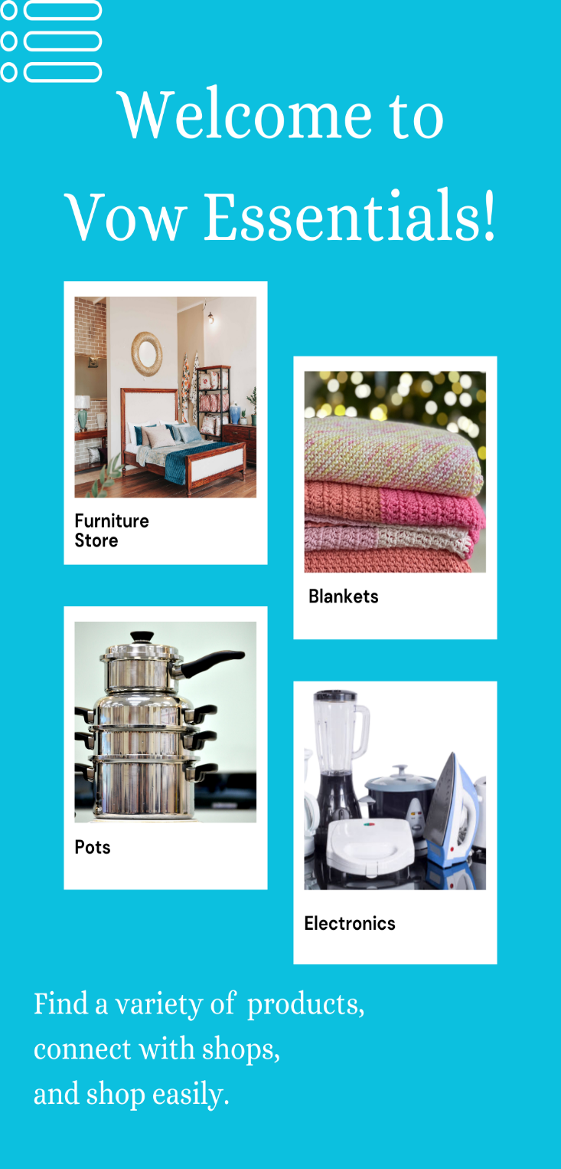

### References

* **McConnell, S. (2006). Software Estimation: Demystifying the Black Art. Microsoft Press**.

“Waterfall vs. Agile Methodology.” 2008. Agile Introduction for Dummies. Retrieved August 13, 2010, from [http://agileintro.wordpress.com/2008/01/04/waterfall-vs agile](http://agileintro.wordpress.com/2008/01/04/waterfall-vs%20agile-methodology/) [methodology/](http://agileintro.wordpress.com/2008/01/04/waterfall-vs%20agile-methodology/)

* <http://eprints.utar.edu.my/3954/1/17ACB05787_FYP.pdf>
* <https://www.shopify.com/blog/best-ecommerce-sites>
* <https://blog.hubspot.com/service/customer-complaints>